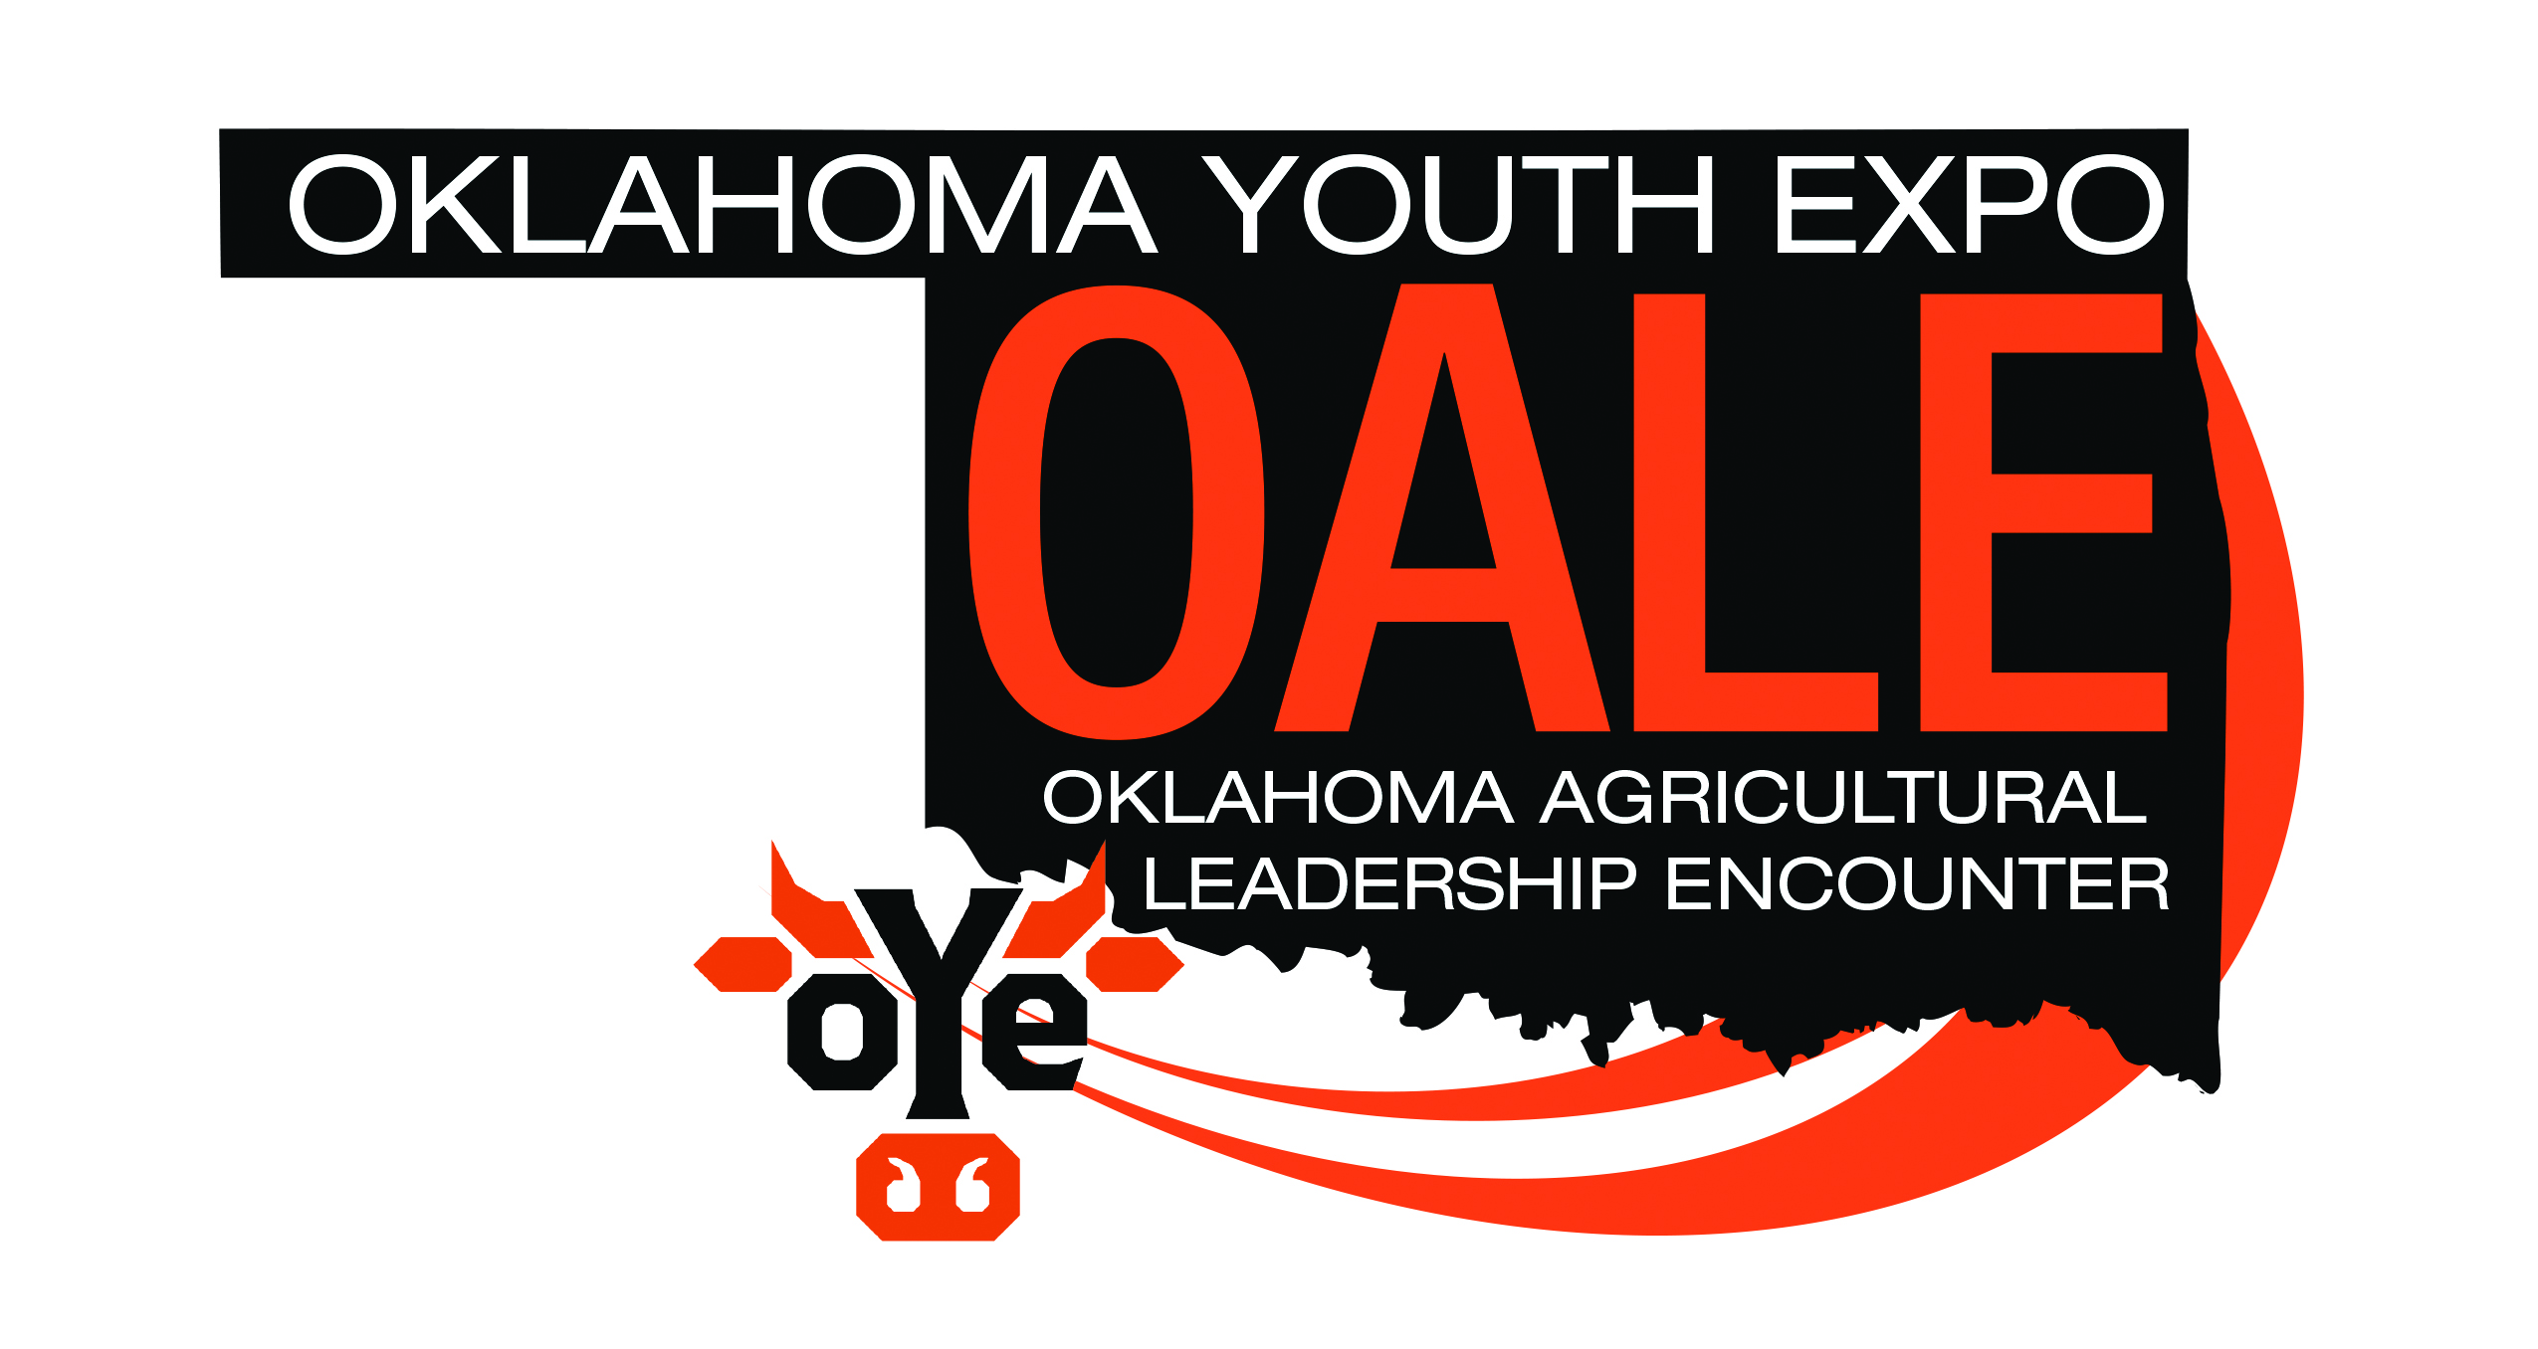

Please insert your photo prior to printing or attach one to this application prior to your interview.
Application Qualifications:
1. The applicant must have a 3.0 GPA or higher.
2. The applicant must be a Junior or Senior in the College of Agriculture and Natural Resource at Oklahoma State University.
3. The applicant must complete all required documents of this application.
4. All applications must be typewritten.
5. The application must be submitted online at oale.okyouthexpo.org.
6. Bring 5 copies of your application (excluding transcripts) with you to your OALE interview.

Name_____________________________________________________________________________________

University Address__________________________________________________________________________

Cell Phone _____________________________ Email _____________________________________________

Major ____________________________________________________________________________________

Month & Year of Graduation______________________________________ GPA___________________

Parent’s Names ____________________________________________________________________________

Parent’s Address ___________________________________________________________________________

Please complete the following questions on a separate sheet of paper:
Both answers combined should not exceed one page total; Times New Roman, 12-point font, Single Spaced
1. Describe your involvement in agriculture; past, present & future.
2. Explain your plans for the next five years.
Additional Requirements:
1. Please include your current resume.
2. Please list three references on your application (no recommendation letters needed), one reference may be an OSU faculty or staff member.
3. Please include one wallet sized photograph of yourself.
4. Please include your current college transcript (unofficial).

OALE MISSION STATEMENT
The Oklahoma Agricultural Leadership Encounter is a program designed to expand the knowledge of the agricultural industry in Oklahoma for today’s young adults. Expansion and extension of the educational component of the Oklahoma Junior Livestock Program through production agriculture, is a major goal of the Oklahoma Youth Expo board of directors and staff. It is only through a stronger concentration on education that future leaders are developed.

The Oklahoma Agricultural Leadership Encounter will assist class members in increasing and utilizing their knowledge base and skills to explore opportunities for the Industry of Agriculture, which will benefit not only our local communities but our state and nation as well. Through various opportunities, class members will visit a variety of agriculturally based companies and organizations across the state. Students will be introduced and exposed to the legislative process and how it affects the agricultural industry. Lastly, students will have the opportunity to join the Oklahoma Youth Expo, “The World’s Largest Junior Livestock Show,” as a valuable staff member.

Oklahoma State University is a natural fit for the Oklahoma Agricultural Leadership Encounter. Oklahoma State University implements and exudes the highest standards possible in terms of education, research, faculty and students. The Oklahoma Youth Expo is proud of its relationship with the oldest land grant university in Oklahoma; Oklahoma State University. Through this partnership, the classroom will be extended in a “hands on manner.” Members of Class XX of the Oklahoma Agricultural Leadership Encounter will have the opportunity to gain two credit hours towards an undergraduate degree at Oklahoma State University.

SPONSORED BY THE OKLAHOMA YOUTH EXPO & OKLAHOMA STATE UNIVERSITY

Dates  AUGUST 26, 2022  Applications Due  SEPTEMBER 13, 2022  Class XX Corteva Agriscience Dinner  SEPTEMBER 14, 2022  Class XX Interviews  Interviews will be scheduled  as your class schedule allows.  SEPTEMBER 19-20, 2022  Northwest Oklahoma  OCTOBER 24-25, 2022  Southwest Oklahoma  NOVEMBER 30- DECEMBER 2, 2022  Southeast Oklahoma | Tentative Dates  JANUARY 16-17, 2023 (MLK day)  Northeast Oklahoma  FEBRUARY 2023  Sirloin Club Banquet  Oklahoma City  Oklahoma State Capitol  MARCH 7-17, 2023  Oklahoma Youth Expo  APRIL 2023  Washington D.C.  APRIL 2023  Remington Park Oklahoma City Trip  SUMMER 2023  International Trip

