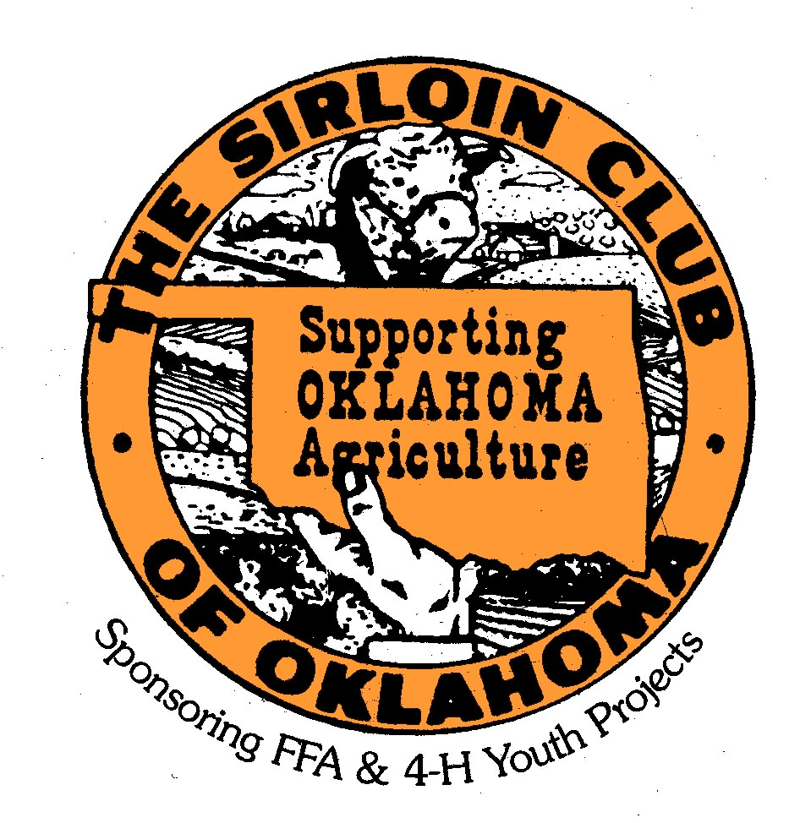

Harley Custer Memorial Scholarship
2023 Application – Deadline: February 1, 2023

Name of Applicant

Mailing Address, City, State, Zip

Phone Number

FFA 4-H
Name of Chapter or County

Parents’ Names

Number of Years Participated at OYE

Name of School
GPA

• Please list any extracurricular activities below:

• Please list any special interests or hobbies below:

Signature of Applicant _________________________________________________________________________________

Signature of Agriculture Teacher or Extension Agent______________________________________________

This application is to be accompanied by a 300-400 word typewritten essay (Times New Roman, 12 point font, and double-spaced), on your personal experiences and point of view on the following subject:

THE JUNIOR LIVESTOCK SHOW PROGRAM – HOW IT HAS HELPED ME GROW AND DEVELOP

Both the application and essay are due no later than
FEBRUARY 1, 2023!

Mail directly to:
Mr. Larry & Mrs. Mary Peck
PO box 339
Sentinel, OK 73664

